DUTIES AND RESPONSIBILITIES

The basic responsibilities of BWSSB is to provide pure drinking water to the citizens living in BBMP area and to convey the sewage water generated from houses to the effluent treatment plant (Sewage Treatment Plant) for treating the sewage to the non potable standards.

Owing to this each individual house will be provided water supply & sanitary connection exclusively.

Apartments and Multi-storeyed buildings are provided higher size single connections as stated above

Water is supplied regularly on designated date & time applicable to concerned areas. In case of interruption of water supply. Board will supply water through its tankers at free of cost.

Water supply & UGD complaints can be recorded in the respective service stations maintained in each areas. The concerned AE / JE / water inspector working in the service station will address the grievance of the public / consumer.

Monthly water bills in-correlation with the consumption will be served to the consumer at the current rates based on per kilo liter basis.

Disputes in respect of water supply & water meter are also addressed by the concerned Assistant Executive Engineer.

Water leakage and over flow of sewage on road are identified by the Board Staff or informed by the complaints will be attended by Board on top priority.

Public taps / public borewells are also maintained by Board.

To improve the quality of service with regards to water supply & UGD system Board will replace the pipelines as required at Board’s cost.
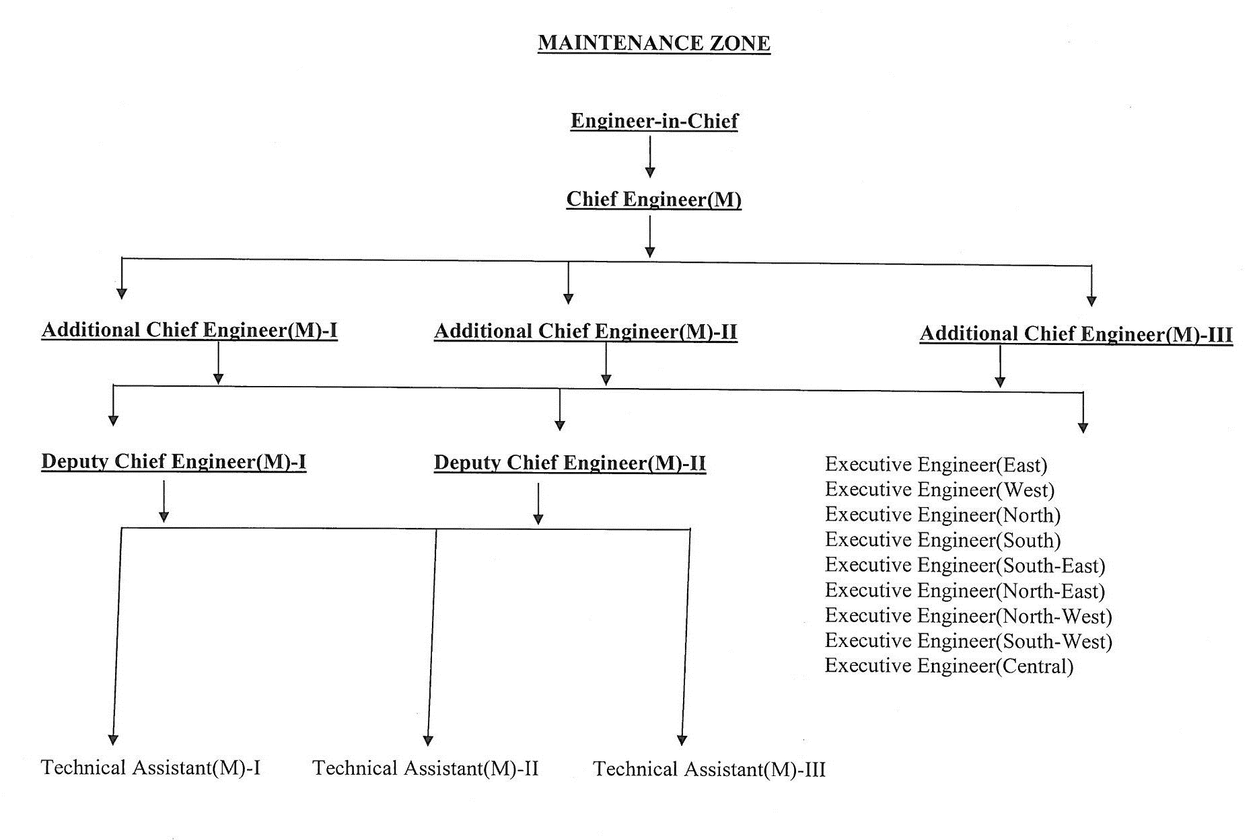

ORGANISATION MAP

Maintenance zone is headed by Engineer-in-Chief with One Chief Engineer. Under them Additional Chief Engineer’s / Executive Engineer’s and Assistant Executive Engineer’s are working.
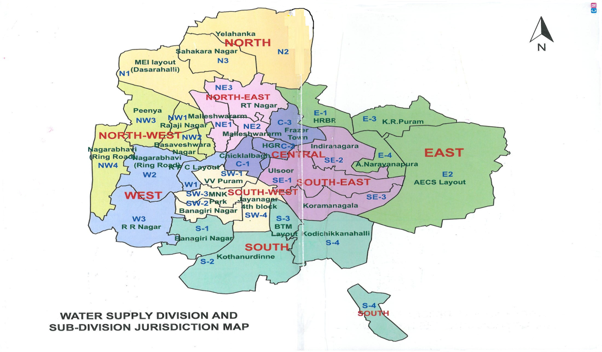

SERVICES

The service area of BWSSB covers 850 sq.km of BBMP. Citizens residing in this area are provided with pure drinking water. Also the sewage generated from the houses is conveyed for treatment purpose. Any slackness in this caused to the citizens, the same will be redressed on priority basis.

COMMUNICATIONS

For the convenience and information of the public to the address the grievances the address of the office service station, phone numbers of concerned Executive Engineer / Assistant Executive Engineer’s / Assistant Engineer / Junior Engineer with names is furnished as follows;

BANGALORE WATER SUPPLY AND SEWERAGE BOARD
TELEPHONE NUMBERS
NAME |  | DESIGNATION |  | OFFICE NO. |  |  | PHONE NUMBER
VIJAYBHASKAR.T.M |  | Chairman |  | 22945100 |  |  | 22945100
JAGHADHISH |  | CAO-S |  | 22945102 |  |  | 9448262001
RAMANNA.R |  | FA&CAO-S
S. KRISHNAPPA |  | EIC |  | 22945105 |  |  | 9845694597
MAHESH .V |  | CE(K) |  | 22945103 |  |  | 9845444095
KEMPARAMAIAH |  | CE(M) |  | 22945253 |  |  | 9845444008
RAMAKRISHNA. S.M. |  | CE(WWM) |  | 22945106 |  |  | 9845444002
RUDRAMURTHY. S.P. |  | CE(P) |  | 22945108 |  |  | 9845444003
NARASIMMA MURTHY .N |  | CE(NI&NW) |  | 22945116 |  |  | 9880335578
RAJU .B.T. |  | ACE(M-1) |  | 22945110 |  |  | 9845444092
SRINIVAS REDDY. H. |  | ACE(M-2) |  |  |  |  | 9845444006
NAGARAJAPPA. D |  | ACE(M-3) |  |  |  |  | 9845444004
SHIVARAJU. G.M. |  | ACE(CMC) |  |  |  |  | 9845444135
SONNAPPA REDDY.T.N. |  | CE&ACE (QA) |  | 22945253 |  |  | 9845444009
RAMESH .S |  | ACE (WWM-1) |  |  |  |  | 9845444145
K.R .MANJUNATH |  | ACE(WWM-2) |  |  |  |  | 9740984168
SHASHIDHARA .G |  | ACE(K-2) |  | 22945113 |  |  | 9845444094
NARAYANA REDDY. B. A |  | ACE (DC-Works) |  |  |  |  | 9845444079
SOMASHEKAR B.S.C. |  | DCE(M)-II |  |  |  |  | 9845444089
GURUPRASHAD SRINATH .K |  | DCE(K)-1 |  | 22945103 |  |  | 9740984173
GURUPRASHAD SRINATH .K |  | TA to CE (K) |  | 22945103 |  |  | 9740984173
VAGHEESHA .M |  | TA to CE (K) |  | 22945103 |  |  | 9740984170
SATHISH CHENDRA |  | TA to CE (P) |  | 22945108 |  |  | 9108024354
GOPAL KRISHNA. H.V. |  | TA to CE (QA) |  | 22945253 |  |  | 9740984176
MOHAMED ISHAQUE |  | TA to CE (QA) |  | 22945253 |  |  | 9482519862
SRINIVAS |  | TA to EIC |  | 22945124
PRAKASH. V |  | TA to EIC |  |  |  |  | 9945233444
RAMESHCHANDRA GUPTA |  | TA to CE(WWM) |  |  |  |  | 9740984179
S.T. SURESH |  | TA to CE (WWM) |  | 22945106 |  |  | 9845444146
RAMESH |  | TA to EIC |  | 22945129 |  |  | 9611197758
VIDYA KANOJI |  | AE |  | 22945124 |  |  | 9845766377
RAJESH S |  | JE |  | 22945124 |  |  | 9886619737
RANGARAJU .Y. |  | JE |  | 22945124 |  |  | 9036511322
SHANKARI. J. |  | AE (K) |  | 22945103 |  |  | 9686566947
VINUTHA .D.S |  | AE |  | 22945108 |  |  | 9611096160
ANURADHA .S.K. |  | AE |  | 22945108 |  |  | 8867452422
MIRAGANJEMANJUNATH |  | AE(WWM) |  | 22945106 |  |  | 9743371110
JAYARAM .R. HEGDE |  | Law Officers |  | 22945122 |  |  | 7022011123
BHAGYALAKSHMI .L |  | Personal Manager |  | 22945238 |  |  | 9844366432
SARALA KUMARI.T.C |  | PRO |  | 22945114 |  |  | 9845443647
Dr. SHANKAR J. |  | Medical Officer |  | 22945220 |  |  | 7022012010
SRINIVAS |  | Asst. Controller |  | 22945217
ALASWAMY |  | AO(R) |  | 22945218 |  |  | 7760993684
RAJANNA .M |  | AO(KMRP) |  |  |  |  | 7760993682
RAVIDRANATH |  | AO(K) |  | 22945214 |  |  | 7760993681
K.K. MOHAN |  | AO(TAX) |  | 22945384 |  |  | 7760993685
S. KARUNAKAR |  | AO(Pension) |  | 22114302 |  |  | 7760993685
HALASWAMY C |  | AO(ICC) |  | 22945382 |  |  | 7760993684
SOMANNANAVAR S.V. |  | Land Acq. officer |  |  |  |  | 9591987950
UMADEVI M.K. |  | PA to CH |  | 22945100 |  |  | 9845546503
SHIVAKUMAR K.M.(RTD) |  | Asst. store officer |  | 22945128 |  |  | 9448039544
RAGHUKUMAR H.N. |  | AEE(CH Office)
PARAMESHA. K.N. |  | AEE
PRASANNAKUMAR |  | AC(IAW) |  | 22945219 |  |  | 7760339683
KAVERI-1 DIVISON , SHIMSHA BHAVAN
SHIVARAJU. G.M. | EE(K-1) |  | 22945211 |  |  | 9845444135
SREENIVASA M. | AEE(K-1)-1 |  |  |  |  | 9845444124
ELIZABETH MICHAEL | AE(K-1)-1 |  |  |  |  | 9591987951
RAJIV. K.N. | AEE(K-1)-2 |  | 22945125 |  |  | 9845444114
PAVAN. N. | AE(K-1)-2 |  |  |  |  | 9844663140
DEVRAJ M | AE(K-1)-2 |  |  |  |  | 9740729300
VINAY KUMAR .S. | AEE(K-1)-2 |  |  |  |  | 9686566941
SREENIVASA. M. | AEE(K-1)-3 |  |  |  |  | 9845444724
MADHUSHREE .P.S | AE(K-1)-3 |  |  |  |  | 9591987952
KAVERI-2 DIVISION, SHIMSHA BHAVAN
NAGARAJ K | EE(K-2) |  | 22945212 |  |  | 9845444120
RAGHU .S | AEE(K-2)-1 |  |  |  |  | 9448473781
DIVYA. P.S. | AE(K-2) |  | 23309555 |  |  | 9686566952
KAVERI-3 DIVISON, SHIMSHA BHAVAN
R.K.SRINATH | EE(K-3) |  |  |  |  | 9845444128
KESHAVHEGADE | AEE(K-3)-1
BASAVARAJ | AE(K-3)-2 |  |  |  |  | 7760990673
RAGHVENDRA. C.P. | AEE(K-3)-2 |  |  |  |  | 9611128372
DHANANJAYA | AEE(K-3)-3 |  |  |  |  | 8147151167
SUMANTH .N. | AE(K-3)-3 |  |  |  |  | 9880866807
KAVERI-4 DIVISION, MALLESHWARAM
RAMANAGOWDA D.E. | EE(K-4) |  | 22945216 |  |  | 9845444125
AKBAR SHARIEF | AEE(K-4)-3 |  | 28434868 |  |  | 9845444119
NAGENDRA BABHU | AEE(K-4)-4 |  |  |  |  | 9611894427
CAUVERY HEAD WORKS (EECH) DIVISION T.K. HALLI
SHIVAPRASAD .B | EE (CH) |  | 0821295745 |  |  | 9686572630
KRISHNEGOWDA | AEE(CH)-1 |  |  |  |  | 9686572631
BALAKRISHNA .N.B. | AEE |  |  |  |  | 9686572634
NARESH .B.K. | AE |  |  |  |  | 9686572633
YASHANTH | JE |  |  |  |  | 9686572637
RANGAIAH .D.S. | JE |  |  |  |  | 9676572638
 | AEE(CH)-3 |  | 0828453280 |  |  | 9686572639
RAMESH .R | AEE |  |  |  |  | 9686572641
NANDISH KUMAR. S.S | JE |  |  |  |  | 9686572642
RANGASWAMY | AEE(CH)-4 |  | 08231295745 |  |  | 9686572643
YATHIRAJ | AE |  |  |  |  | 9591988967
DODDAVEERAPPA | JE |  |  |  |  | 9686572645
KAVERI ELECTRICAL DIVISON, SHIMSHA BHAVAN
SOMASHEKAR B.M | EE (K) Ele |  |  |  |  | 9448068823
VENKATESH S.V. | AEE (Ele)-1 |  |  |  |  | 9845444118
CHANDRASHEKAR PRASAD.T | AE(Ele)-1 |  |  |  |  | 9591987954
HEMANTH KUMAR S.R. | AEE (Ele)-2 |  |  |  |  | 9591987953
MURULI .C.P. | JE (K) Ele-2 |  |  |  |  | 9845451382
SLUM DEVELOPMENT COMPONENT DIVISION CAUVERY BHAVAN
 | EE(SDC)
PRABHUDEVA T |  |  |  |  |  | 9845312814
NEELAGUNDA ROOPA |  |  |  |  |  | 990293379
REVENUE INPROVEMENT DIVISION, 7TH FLOOR CAUVERY BHAVAN
PADMARAJU T.C | EE (R I) |  |  |  |  | 963242255-----
NALINI | AE (R I) |  |  |  |  | 9741925536
WEST DIVISON ARKAVATHY BHAVANA (R.P.C. LAYOUT)
NITHYANDAKUMAR.V | EE(W) |  | 22945171 |  |  | 9845444059
SAMBEGOWDA | Teach Officer |  | 22945171 |  |  | 9741245906
SUNITHA .K.L. | AE |  | 22945171 |  |  | 9902510105
SURESH | AEE W-1 |  | 23500013 |  |  | 9845444069
DASTAGIRI BASHA P. | JE |  | 22945186 |  |  | 9980603214
RAMANUJA | AEE(W-2) |  | 23212181 |  |  | 9845444060
SOWMYA RANI | AE |  |  |  |  | 9845546502
ROOPA | JE |  |  |  |  | 9845444126
MAHESH | JE |  |  |  |  | 9845444072
KRISHNAPPA | JE |  |  |  |  | 9845444062
RAMEGOWDA | JE |  |  |  |  | 9845444061
MALLIKARJUN | AEE(W-3) |  |  |  |  | 9740984165
KUMAR.S | AE |  |  |  |  | 9448684960
CHENNAPPA.G | JE |  |  |  |  | 9845444063
NORTH WEST DIVISION WEST OF CHORD ROAD
MANJUNA.T.H | EE(NW) |  | 23491123 |  |  | 9611897424
BINDU .T | Tech. Officer |  | 23491123 |  |  | 9980402920
ASHWINI .H.J. | JE |  | 23491123 |  |  | 9844060449
HARINATH | AEE (NW)-1 |  | 22945176 |  |  | 9980214906
SOMANATH(N.L.O.) | JE(NW)-1 |  | 22945178 |  |  | 9740984172
SOMANTH (M.L. PURAM) | JE(NW-1)-1 |  | 22945387 |  |  | 9740984172
GURUMALLESH | AEE(NW)-2 |  | 22945184 |  |  | 9845444073
RAJENDRA.R | JE(NW)-2 |  | 22945185 |  |  | 9845444076
KRISHNE GOWDA.(A.D. HALLI) | JE (NW)-2 |  | 22945185 |  |  | 9845444074
RUDRAMUNI.T.V | AEE(NW)-3 |  | 28372030 |  |  | 9740984166
GHOUSE INAMDAR (PEENYA) | AE |  | 22945213 |  |  | 9845444068
KALPANA(PEENYA DASARAHALLI) | AE |  |  |  |  | 9980914310
RAVIKUMAR (HEGGANAHALLI) | JE |  |  |  |  | 8746975985
HARIKUMAR.L | AEE (NW)-4 |  |  |  |  | 9591987962
CHENNESHAPPA.H.G | JE |  |  |  |  | 9448970393
NORT DIVISION 18TH CORSS MALLSHWARAM
AMRUTESH P.L. | EE(N) |  | 22945130 |  |  | 9845444139
MALLIKARJU NA REDDY | Tech. Officer (EE) |  |  |  |  | 8197222192
KEERTHANA | AE |  |  |  |  | 7259031533
PURUSHOTHAM .B.G. | AEE(N-1) |  | 23240698 |  |  | 9686448013
DEVARJ | JE |  |  |  |  | 9972176114
SRINIVAS | AEE(N-2) |  | 28562829 |  |  | 9740984163
NARAYANA SWAMY .B | JE |  |  |  |  | 9449975161
RAMANAND | AEE(N-3) |  | 23621888 |  |  | 9845444102
BASAVARAJU | AE |  |  |  |  | 9886146936
RAJESH | JE |  |  |  |  | 9901753078
NORTH EAST DIVISION, 18TH CROSS, MALLESHWARAM
RAJUSHANTHKUMAR | EE(NE) |  | 22945124 |  |  | 9845444013
BINDU K.C. | Tech. Officer |  | 22945124 |  |  | 7760990542
ANASUYA D | AEE |  | 22945124 |  |  | 9731156349
DALAYATH B.S. | AEE NE-1 |  | 22945131 |  |  | 9900469774
HARSHA | AE |  |  |  |  | 9740061183
HANUMANTHA RAJU | JE |  | 22945132 |  |  | 9902650062
LAKSHMINARASIMHAIAH G.M. | JE |  | 22945189 |  |  | 9845444080
SHASHIDHAR | AEE NE-2 |  | 22945135 |  |  | 9845444020
LAKSHMINARASIMHAIAH G.M. | JE(I/C) |  | 22945138 |  |  | 9538682255
SHWETHA V | JE |  | 22945136 |  |  | 7406677997
CHENNA BASAIAH | AEE NE-3 |  | 22945139 |  |  | 9845444025
HUSEN BASHA M.N | AE |  |  |  |  | 9845444023
DAVAL SAB | JE |  | 22945141 |  |  | 9900171178
LATHIEEF | JE |  |  |  |  | 8867388732
DEVARAJ | JE |  |  |  |  | 9731405535
CENTRAL DIVISION, HIGH GROUNDS
KOTEKAR R.S. | EE Central |  | 22945187 |  |  | 9845444078
JAYASHAKAR. | AEE C-1 |  | 22945188 |  |  | 9845444081
SHIVARAM S.G. | AE |  |  |  |  | 9591987963
MADHUSUDHAN | AEE C-2 |  | 22945191 |  |  | 9845444071
RAGHU R.(H.G.R.) | AE |  | 22945191 |  |  | 9845444084
RAJESH D. | JE |  | 22945192 |  |  | 9972962038
SUHAS | AEE(C-3) |  | 22945167 |  |  | 9845444053
PRAVEEN | JE |  | 22945167 |  |  | 9480245987
RAGHU | JE |  |  |  |  | 9845444084
SOUTH DIVISION 4TH BLOCK, JAYANAGAR
RAJASHEKARAPPA | EE South |  | 22945143 |  |  | 9845444050
MAHESH | AEE S-1 |  | 22945198 |  |  | 9845444036
CHETHAN | AE |  | 22945146 |  |  | 7760990673
SHREEDHAR | JE |  |  |  |  | 9945172254
PRADEEP | AEE S-2 |  | 22945267 |  |  | 9740984164
NAGARAJ S.R | JE |  | 22945230 |  |  | 988652469
ASHOK GOWDA | AEE S-3 |  | 22945151 |  |  | 9845444042
VENAY BABU | JE |  | 22945390 |  |  | 9845444043
DUSHYANTH | JE(I/C) |  |  |  |  | 8904778179
NAGENDRA | AEE S-4 |  | 22945151 |  |  | 9845444037
SAHEBANNA | JE |  | 22945231 |  |  | 9845444034
SANTHOSH PRASAD | JE |  | 22945154 |  |  | 9845444154
SOUTH WEST DIVISION, 4TH BLOCK, JAYANGAR
GOPALA GOWDA H.P. | EE (SW) |  | 22945196 |  |  | 9845444029
RAMA MURTHY H.M | AEE SW-1 |  | 22945193 |  |  | 9845444085
NAGARAJU | AE |  | 22945195 |  |  | 9845444087
HEMANTH KUMAR | AE |  | 22945195 |  |  | 9845444048
PRAHLAD | JE |  | 22945195 |  |  | 9845444154
SHARIFF | JE |  | 22945156 |  |  | 9845444086
DEEPAK S. | AEE SW-2 |  | 22945144 |  |  | 9845444113
SHASHI KIRAN | AE |  | 22945147 |  |  | 9845444031
SRINIVAS | AEE SW-3 |  | 22945155 |  |  | 9845444041
DINESH | AE |  | 22945155 |  |  | 9845444110
SNEHA V | AE |  | 22945157 |  |  | 9845444105
RAJEEV J. | AEE SW-4 |  | 22945148 |  |  | 9945518971
RAGHVENDRA R. | AE |  |  |  |  | 9591988970
AKRAM | JE |  |  |  |  | 9845444153
SOUTH EAST DIVISON INDRANAGAR
SATHISH | EE SE |  | 22945169 |  |  | 9845444083
DHARMESH | AEE SE-1 |  | 22945169 |  |  | 9845444090
RAGHAVENDRA | AE |  | 22945162 |  |  | 9845444049
JAYAPRAKASH R. | AE |  | 22945159 |  |  | 9591988969
VENUGOPAL | AEE SE-2 |  |  |  |  | 9845444070
LOHITH K PRAKASH | JE |  |  |  |  | 9880874543
JAGADISH.R | JE |  |  |  |  | 9845444052
JAGADISH R. | JE |  | 22945160 |  |  | 8123387316
LAKHMI KANTH | AEE SE-3 |  | 22945243 |  |  | 9845444121
MOHAN S.T | AE |  | 22945153 |  |  | 9845444056
NAVEEN | JE |  |  |  |  | 9686566948
EAST DIVISION, INDIRA NAGAR
CHANDRAMOULLESHWAR | EE East |  | 22945158 |  |  | 9845444045
BASAVARAJU N | Technical officer |  |  |  |  | 9686566953
CHALAPATHI | AEE E-1 |  | 22945170 |  |  | 9845444150
ANAND S | AE |  | 22945200 |  |  | 9686566954
KARTHIK M. | JE |  | 22945170 |  |  | 9845444058
NANJUNDAIAH | JE |  | 22945200
RAMESH S.V. | AEE E-2 |  | 22945115 |  |  | 9740984161
HANUMANTHA GUNTY. | AE |  |  |  |  | 9845006611
VINAYKUAR | AE |  | 22945170 |  |  | 9845444039
S.B. RAMESH | AE |  |  |  |  | 9482516999
KANTHA | E-3 |  |  |  |  | 9632349063
UMAHEBBL | AE |  |  |  |  | 9845709935
LOKESH | AE |  |  |  |  | 9532422553
MANJUNATH | JE |  |  |  |  | 9535184378
SANTHOSH | JE |  |  |  |  | 9591987968
DINESH BALU | JE |  |  |  |  | 9591987971
KUMARSWAMY | JE |  |  |  |  | 9060341644
RAJASHEKAR A | AEE E-4 |  | 28510008 |  |  | 9740984162
VENKATARAMANAPPA | AE |  |  |  |  | 9845444051
SHRIDHAR D. | AE |  |  |  |  | 9845709944
QUALITY ASSURANCE DIVISION 18TH CROSS MALLESWARAM
CHENDRAPRABHA | EE |  | 22945201 |  |  | 9740984178
RAGHUKUMAR | AEE (QA)-2 |  | 22945201
KEMPAIAH M | AEE (QA)-3 |  | 22945201 |  |  | 9900000564
PREETHI J. | JE (QA) |  | 22945201 |  |  | 7760990676
PUMPING STATION & BOREWELL DIVISION, MALLESWARAM
JAYARAM N.S. | EE |  | 23560282 |  |  | 9845444117
SRISHYLA POOJARI | JE |  |  |  |  | 8147312451
RAJASHEKAR B.S. | AEE |  |  |  |  | 9845444151
MANJUNAG J.C. | AE |  |  |  |  | 9845444142
VEDAMURTHY D.S. | JE(O) |  |  |  |  | 9035973135
RAMANUJA | AEE(ps &bw)-2 |  |  |  |  | 9845444112
MUKUND. C. MAGADI | AEE(ps &bw)-3 |  |  |  |  | 9845451381
SHAIK MOHAMAD | AE |  |  |  |  | 9591987961
SHIVARUDRAIAH B.L. | AEE (ps&bw)-4 |  |  |  |  | 9741501799
RAVICHANDRA S | JE(O) |  |  |  |  | 9448312355
KEMPARAJU M.R. | JE(O) |  |  |  |  | 9901229472
CENTRAL STORES DIVISION 18TH CROSS MALLESHWARAM
H GHANGADHAR MURTHY | EEST |  | 22945205 |  |  | 9740984169
SUDHIR S | AEE (ST) |  | 22945205 |  |  | 8884254205
RANGASWAMY D | AE |  | 22945205 |  |  | 9480493984
BABURAO A | Ast. store officer |  | 22945205 |  |  | 9591172904
CENTRAL STORES DIVISION, 18TH CROSS MALLESWARAM
KOTEKAR | EE |  |  |  |  | 9845444078
SUDHIR S. | AEE(ST) |  | 22945205 |  |  | 8884254205
RANGASWAMY D. | AE |  | 22945205 |  |  | 9480493984
BABURAO A. | Asst. Store Officer |  | 22945205 |  |  | 9591172904
REVENUE BILLING & COLLECTION DIVISION, 7TH FLOOR,CAUVERY BHAVAN
NARAHARI S. | EE(RBC) |  | 22945109 |  |  | 9880668431
MADHUSUDAN T | AEE (RBC) |  |  |  |  | 9845444137
VEENA A.S. | AEE(RBC) |  |  |  |  | 9740984171
SHILPA V | AE(RBC) |  |  |  |  | 9891987958
WATER DUDIT, NETWORK PLANNING & DESIGN DIVISION, 7THFLOOR CAUVERY BHAVAN
R.SRINIVASAN | EE(WA,NP&  D) |  | 22945109
MAHESHWARAPPA V.B. | AEE(WA,NP&  D) |  |  |  |  | 7760990274
SADANAND P. KAKHANDAKI | AE(WA, NP&D) |  |  |  |  | 9591987960
BUILDING AND VEHICLE MAINTENANCE
RAMAKRISHNA.K.R | EE(B&V,M) |  |  |  |  | 9972006302
RAGHU KUMAR.N | AEE(B&V,M) |  |  |  |  | 9945004477
RAMESH CHAKARAVARTHI | AEE(B&V,M)-3 |  |  |  |  | 9845444030
SOWBHAGYA.S | AE |  |  |  |  | 8197998490
RAGAVENDRA.M | JE |  |  |  |  | 9982017540
SRINIVAS.P.M | JE |  |  |  |  | 9035570641
VINAYKUMAR.P.B | JE(I.C) |  |  |  |  | 8184079109
USHARANI.A | JE(I.C) |  |  |  |  | 9448551452
WASTE WATER MANAGEMENT , VRISHABAVATHI VALLEY
GURURAJA.L | EE(WWM-V.V) |  | 22945206 |  |  | 9845444032
MAHADEVEGOWDA.M | AEE(WWM-V.V-2) |  |  |  |  | 9845444108
RAJSHEKAR.K.C | AEE(WWM-V.V-1) |  |  |  |  | 9731300108
SHILPA HALLIYALA | AE(WWM-V.V) |  |  |  |  | 9611820287
MANJUNATH.R.S | AE(WWM-V.V-1) |  |  |  |  | 9945246829
PARASHIVAMURTHY | AE(WWM-V.V-2) |  |  |  |  | 9845444152
DEEPA.J | JE(WWM-V.V-2) |  |  |  |  | 994595666
WASTE WATER MANAGEMENT K&C VALLEY
VENKATESH.H | EE(WWM-K&C) |  |  |  |  | 9686572632
UDAYSHANKAR | AEE( -K&C-1) |  |  |  |  | 9686572470
SRINIVAS DINKAR | AEE(WWM-K&C-2) |  |  |  |  | 9845444109
MOHAMMED HANIF | AEE(WWM-K&C-1) |  |  |  |  | 9980519212
WASTE WATER MANAGEMENT DIVISION, HEBBAL
SRIRAM.T | EE(WWM-H) |  |  |  |  | 9880517763
VENKATASHIVAREDDY | AEE(WWM-H-1) |  |  |  |  | 7760993675
NAVANEETH.K.L | AEE |  |  |  |  | 9686745400
BHAGYALAKSHMI | JE |  |  |  |  | 9740061631
STP-V. VALLEY, HEBBAL DIVISION
KUMAR.V.C | EE(STP.V&H) |  | 28600907 |  |  | 9686572636
UMESH.T | AEE(STP.V&H-2) |  |  |  |  | 9845444090
MANJUNATH.M.N | AE(STP.V&H) |  |  |  |  | 9591874457
GIRIVAS.M.N | JE(STP.V&H) |  |  |  |  | 9740448294
STP, KORMANGALA, CHENNAGATTA DIVISION
PRUFJKFKSF
JAYALAKSHMI.B.S | AEE(STP-K&C-1) |  | 22945207 |  |  | 9845444096
CMC-1 DIVISION, ANANDARAO CIRCLE
VASUDEVACHAR.K | EE(CMC-1) |  |  |  |  | 9845444132
BHARATH KUMAR.S | AEE(CMC-1) |  |  |  |  | 7760963672
ANAND.K.M | AEE(CMC-) |  |  |  |  | 9663310096
SUMANTH.N | AE |  |  |  |  | 9880866807
CMC-1 DIVISION, ANANDARAO CIRCLE
JAYARAMAIHA.M | EE(CMC-2_) |  | 22945203 |  |  | 9448131256
J.DARANESH | AEE(CMC-2)-1 |  |  |  |  | 9845444012
SRINIVAS.T.R | AEE(CMC-2) |  |  |  |  | 9731300882
CMC-3 DIVISION, 18TH CROSS, MALLESHWARAM
CHANDRASHEKAR.K | EE(CMC-3) |  | 22945368 |  |  | 98845451380
RAVINDRAKUMAR | AEE(CMC-3)-1 |  |  |  |  | 9845444035
GANGADAR.B.C | AEE(CMC-3)-2 |  |  |  |  | 9845444091
CMC-4 DIVISION, SHIMSHA BHAVAN
NAGARAJ.B.K | EE(CMC-4) |  |  |  | 22945237 | 9845444097
DESAI | AE |  |  |  |  | 9591987965
SANTH KUMAR.V | AEE(CMC)-1 |  |  |  |  | 9663305105
GANGADAR MURTHY | AEE(CMC-4)-2 |  |  |  |  | 9740984169
MOHAMMAD ARIFF | AEE(CMC-4)-3 |  |  |  |  | 9845444093
DC WORKS DIVISION ANANDARAO CIRCLE
PRABHUDEV.B.C | EE |  |  |  | 22945202 | 9902933799
RENUKUMAR | AEE(DC-1) |  |  |  |  | 7760963673
LINGABASAPPA.S.P. | JE |  |  |  |  | 9591987964
NEW INITIATIVES AND PUBLIC OUTRICH, CAUVERY BHAVAN
DR. RAVINDRA P.N | EE(NI&PO) |  |  |  | 22131105 | 9845444127
NARAYANSWAMY.C | AEE(NI&PO) |  |  |  |  | 9686785300
SMITHA.G.V | AE(NI&PO) |  |  |  | 22131105 | 9900047633
REKHA.K | JE(NI&PO) |  |  |  |  | 9916447126
NEW WATER DIVISION CAUVERY BHAVAN
SURESHBABU.M | EE(NW) |  |  |  |  | 9740984168
RAVINDRA.H.S | AEE(NW-1) |  |  |  |  | 7760993676
SANGEETHA.S | AEE(NW-2) |  |  |  |  | 7760993678
SUNIL KUMAR.G.S | AE(NW) |  |  |  |  | 9686572469

