Save Water Save Bengaluru Campaign

Bengaluru DC V. Shankar.! It was a pleasant surprise. He was on his regular walk at yediyur lake, saw our play and instantly responded to Mayura Channel.

Private High school HM on the play. she wants a show in her school. Very heart warming responses from super senior citizens on the play made them to introspect their mistakes. Sharing their views with Mayura Channel reporter.

Times of India photographer and the reporter interacted with artists. In 7th Block, jayanagar Residents Wellfare association function. WATER AND CONSERVATION was the topic. Our play was a huge hit. Nearly 300 audience and an excellent response to the play. Sarathi's committed artists who made our Mission Possible.

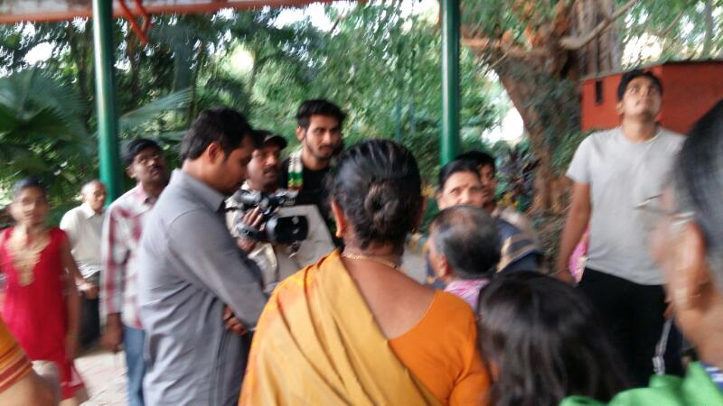
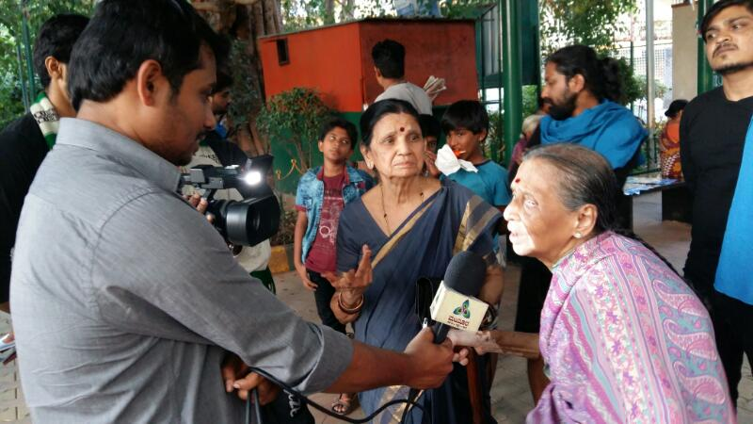
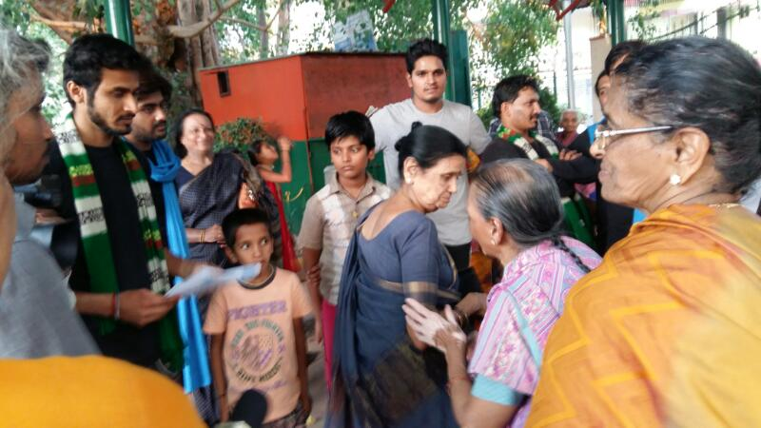
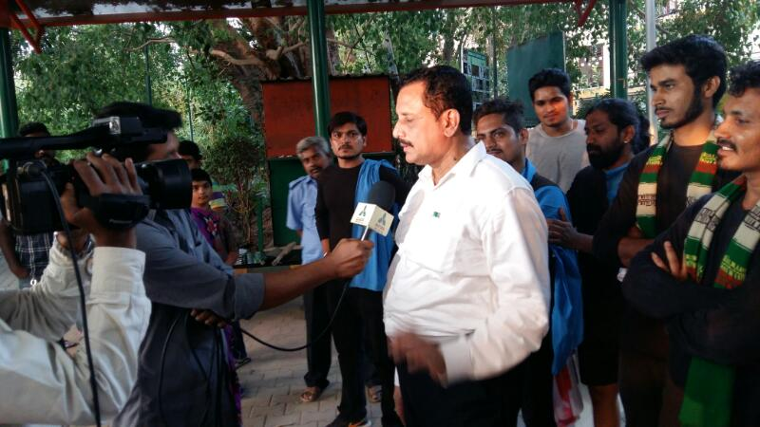
“Save Water -Save Bengaluru” program held at yadiyur lake park on 15.04.2017

In VASANTOTSAVA event, I shamantha also spoke on the issue. Our play high lights Save water.I as a Development Media Professional spoke on why we need to save water.
I have been documenting water, sanitation, hygiene, health and development issues in both print and electronic media. Water needs holistic approach and it's interlinked with Development of the country. Regarding this a global perspective, WHO definition of health and water, UNICEF report on water boren diseases which are causing high infant mortality rate etc in spite of our GDP growth .
Understanding Water is a major challenge and we the people of bengaluru why we should save water was my topic. Cauvery basin farmers have sacrificed their crop for city's drinking purpose. So, it is the moral, emotional and official obligation of Bengaluru to save and respect water.

Later, How to Save Water..? Is the is question. As a solution Sarathi performed street play suggesting multiple choices. It was a best combination and we received requests from many RWA and educational institutions.

This event was on 15th Saturday at 6pm. Nearly 300 and odd audience attended. Dr madhu mathi, oncho pathologist, scientists like PNN Rao, Chetan, president of Welfare organization, Kishore, senior manager from SBI, RR Nagar branch, etc a few names to mention.
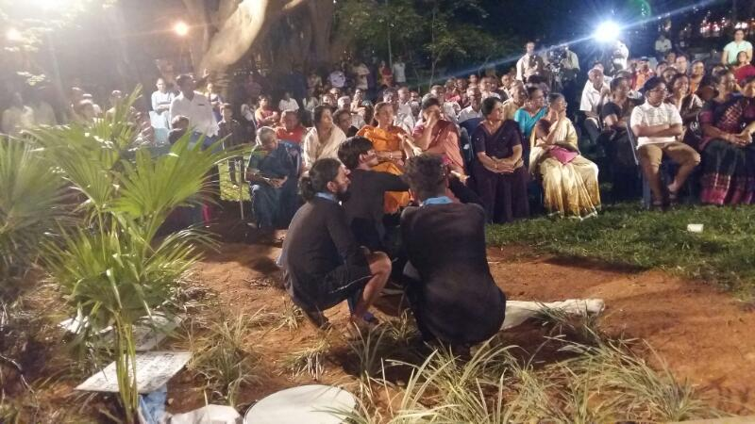
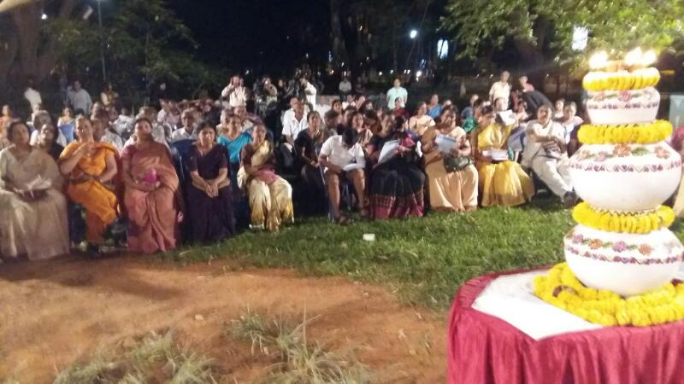

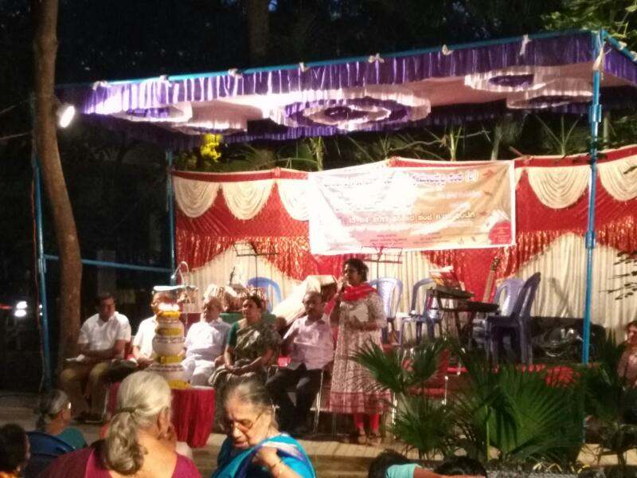

“Save Water -Save Bengaluru” program held at Gandhi bazaar circle,
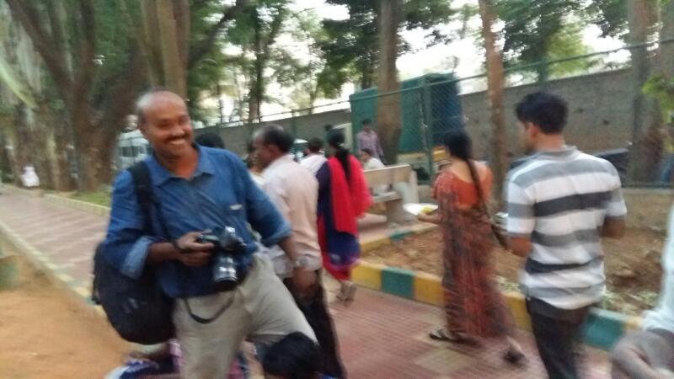
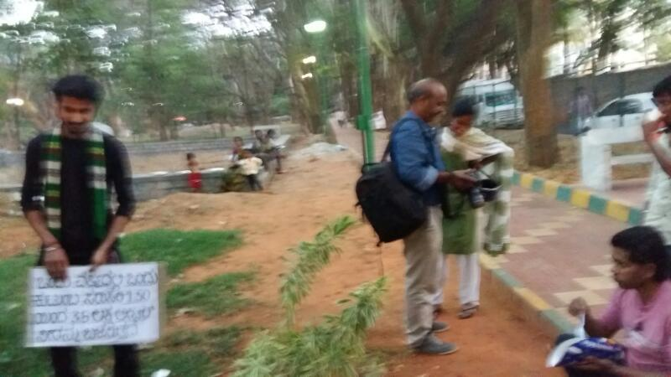
near Krishna rao park on 15.04.2017

Shamantha
Sarathi

Save Water Save Bengaluru Campaign by
The Bharath Scouts and Guides

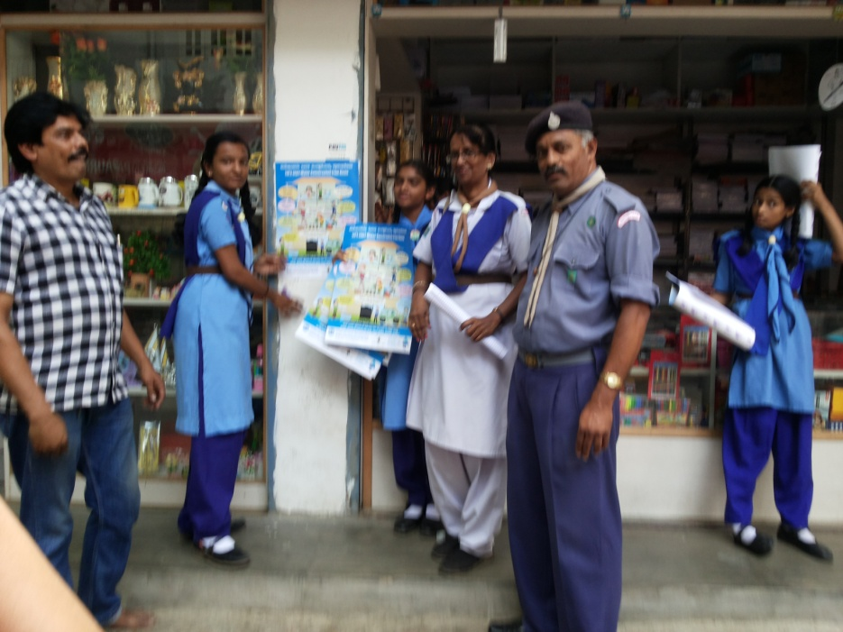

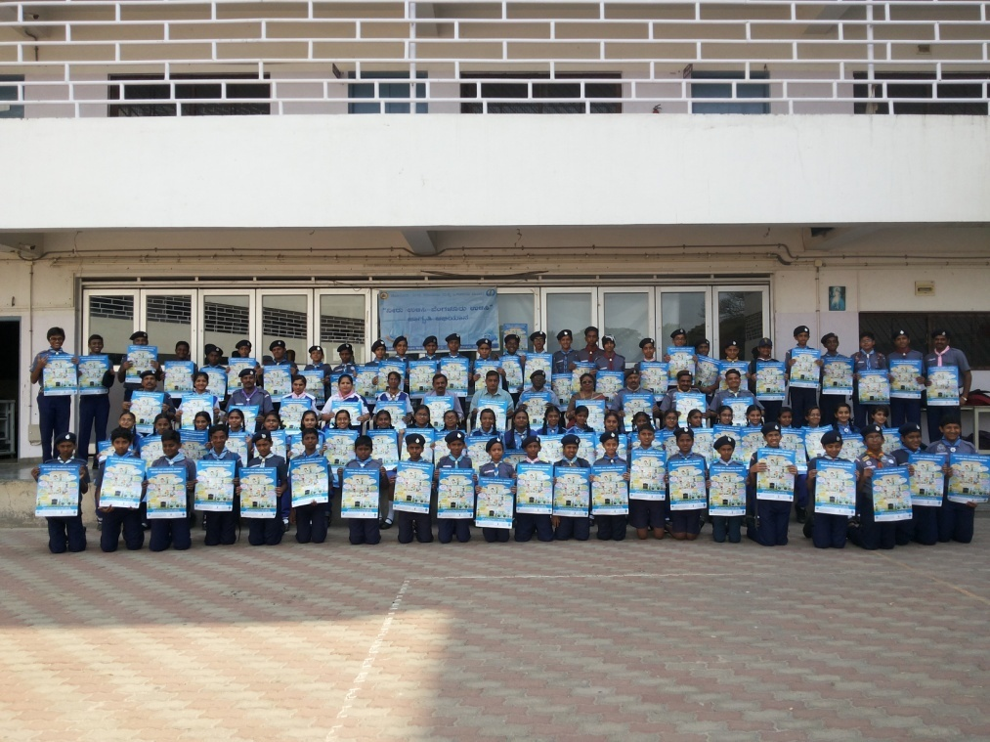

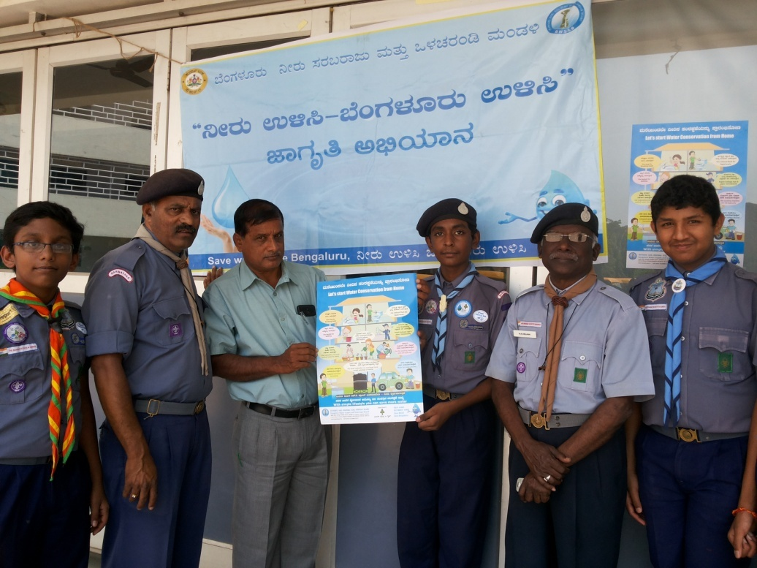

Save Water Save Bengaluru Campaign by BPAC
at Kanteerava stadium on 25.03.2017
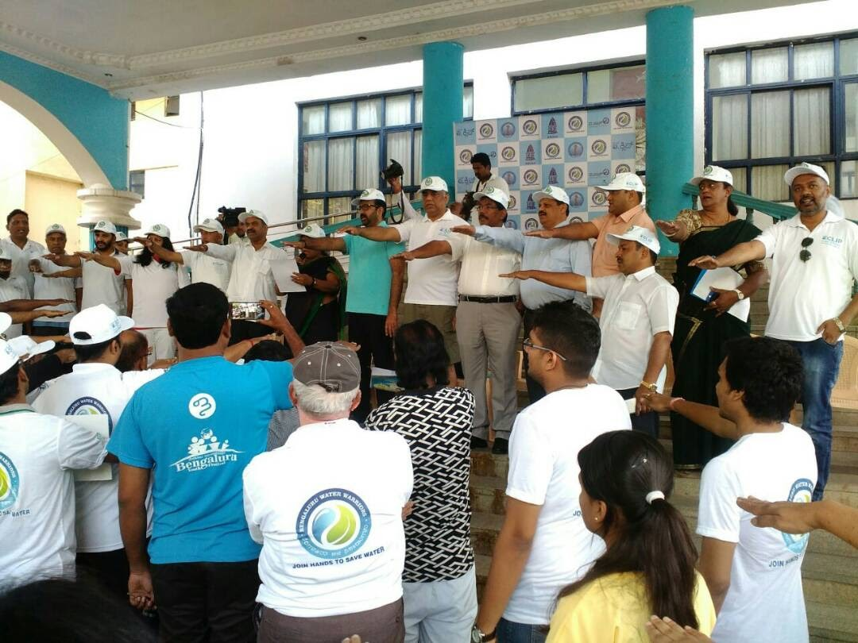
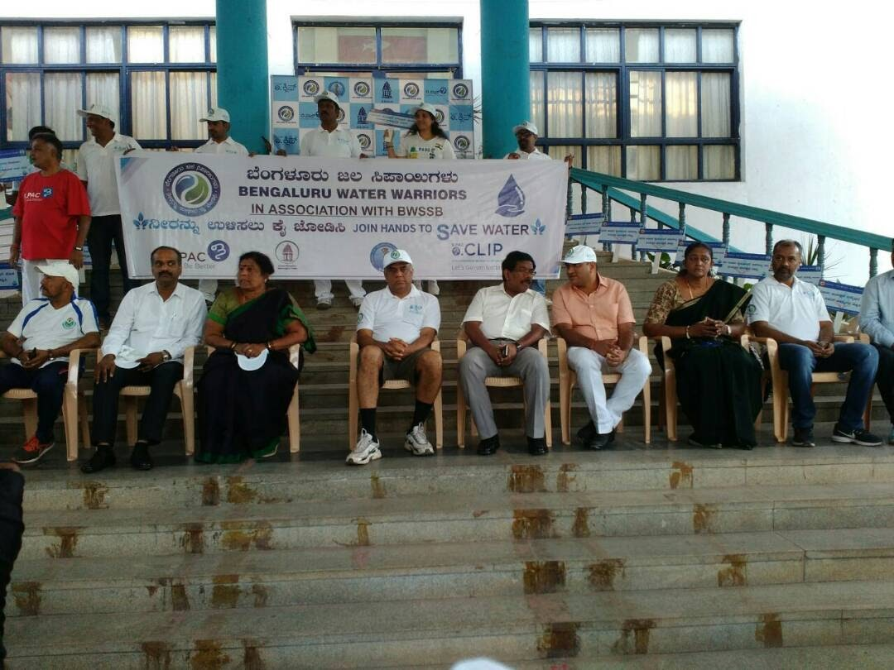

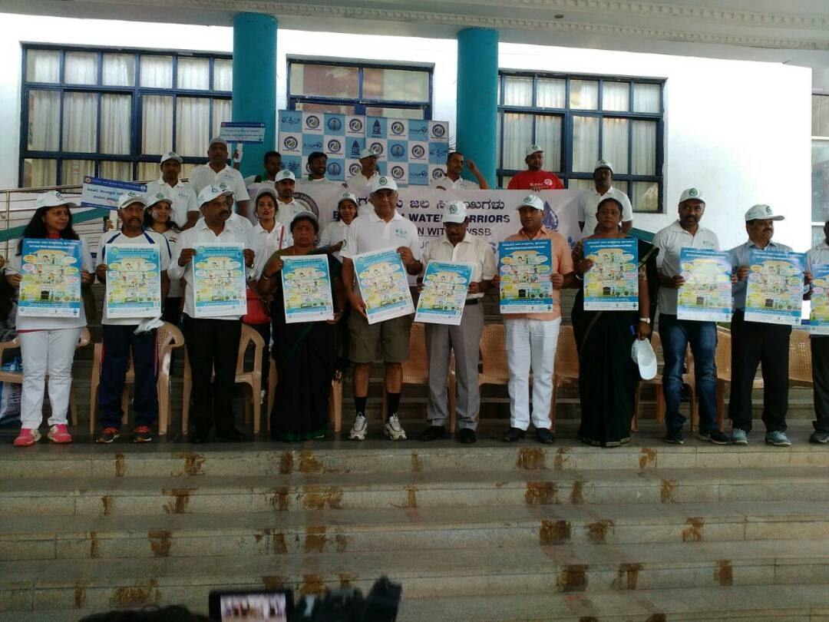

Save Water Save Bengaluru Campaign by BPAC
at Cubbon Park on 09.04.2017

