Progress of M/s. Sarathi of Save Water Campaign
Sarathi Organization started it’s campaign on 25th of march and continued on 26th at karisandra ward office, number 161. We covered 10 places in south Bengaluru. Details are self explanatory from community. 1st and 2nd of April sarathi organization’s 2nd show at white field area, ward no.60. covered 10 paces in that area.
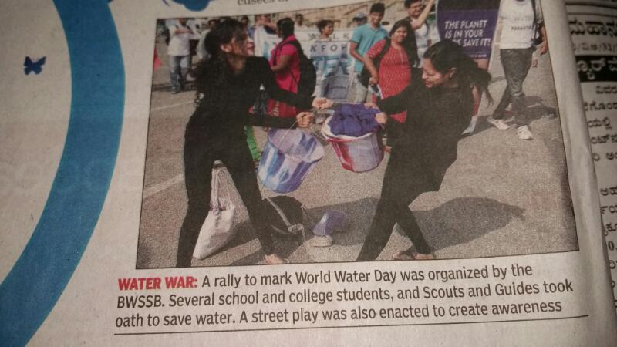
I had a presentation of on health dept and was able to convey the message and to link the subject in their state level seminar. Target audience were health educators. Sarathi’s inaugural show on save water is great hit. This event at karisandra ward office.
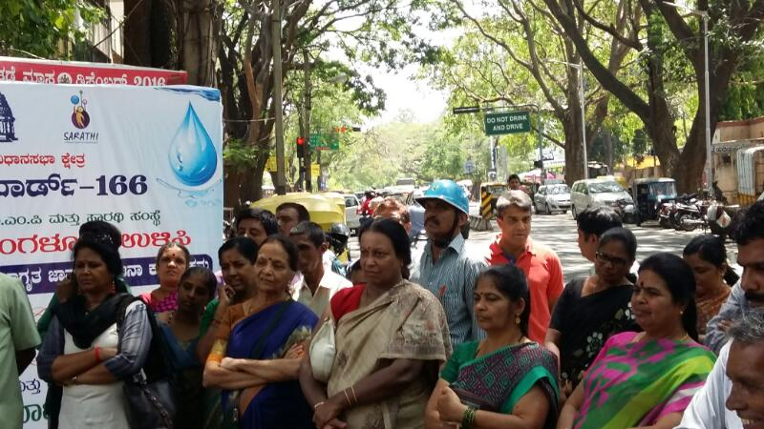
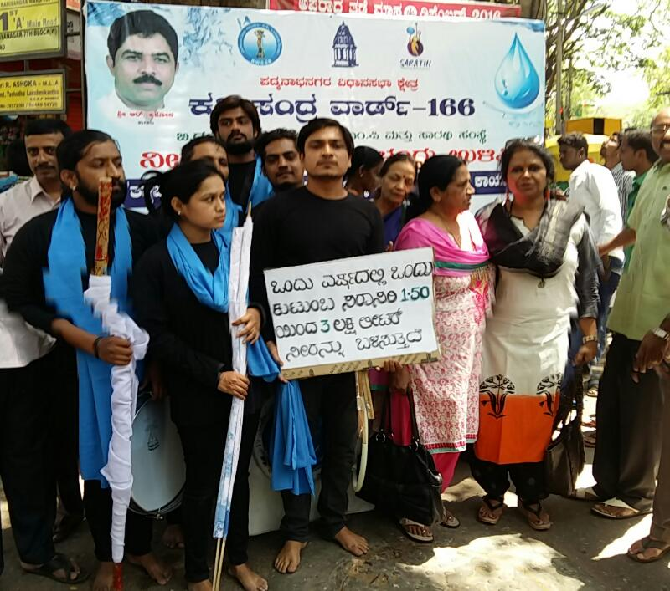

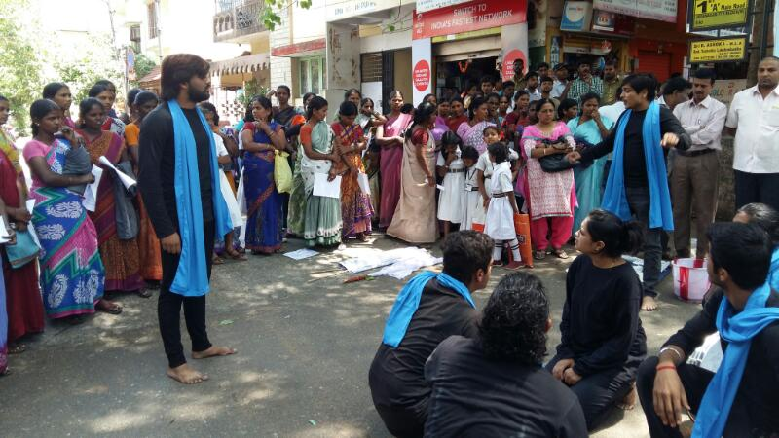
Street play performed on 25.03.2017 at Karisandra
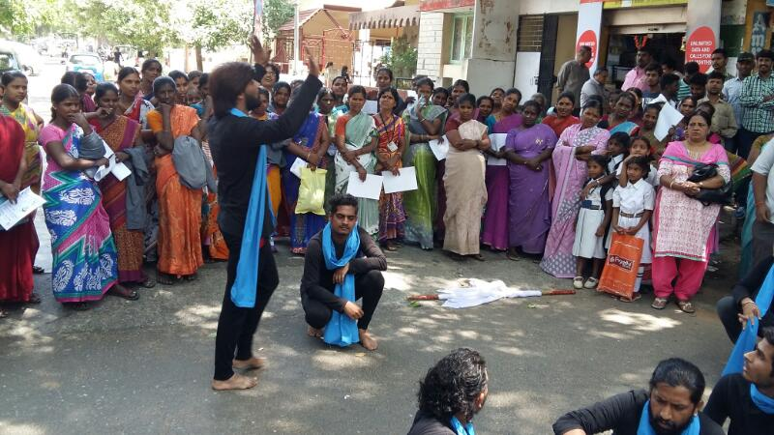
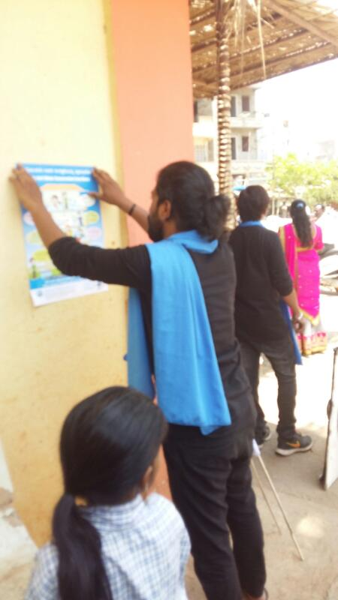
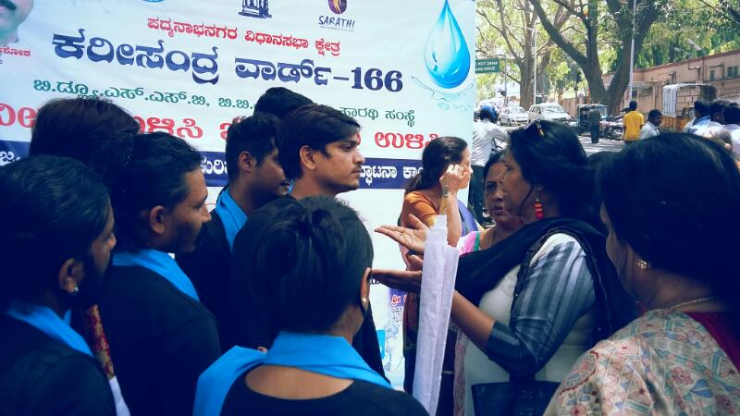

Save water save bengaluru campaign is BWSSB’s initiative with sarathi organization in bengaluru. Purpose of this campaign is to create awareness on how to use water in this rainless drought city. This street play NEERU BEKU will be performed by trained artists across the city. Our 1st inaugural show is before audience were poura karmikas of yadiyur ward.166. the concerned corporator yashodha lakshmikanth joined hands with sarathi and we were able to perform , interact with cross section of the community, like slums, low income group to elites.
Currently entire campaign is focusing only on water management and in the 2nd phase campaign educate people on rain water hatvesting. Most importantly water is an emotional issue and one need to understand it’s value and scarcity. With this intention, we tried to educate poura karmikas as our audience. Our corporator’s involvement in this regard is a model and sarathi look forward to work with other BBMP members in the city.
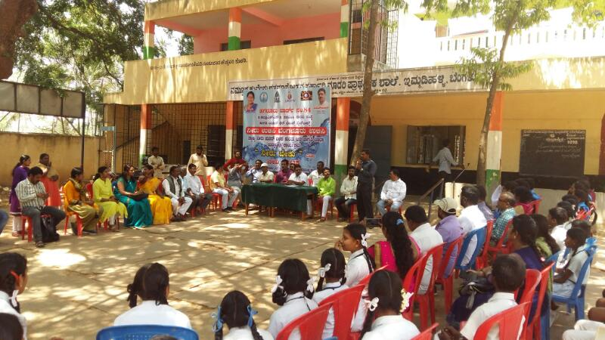
Street play performed on 02.04.2017 at Govt higher primary school Immadi halli White field.
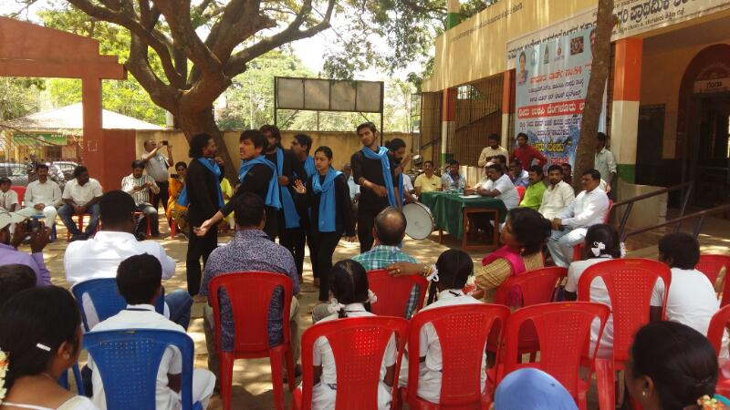
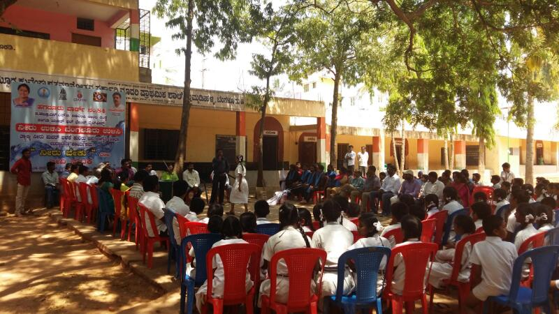
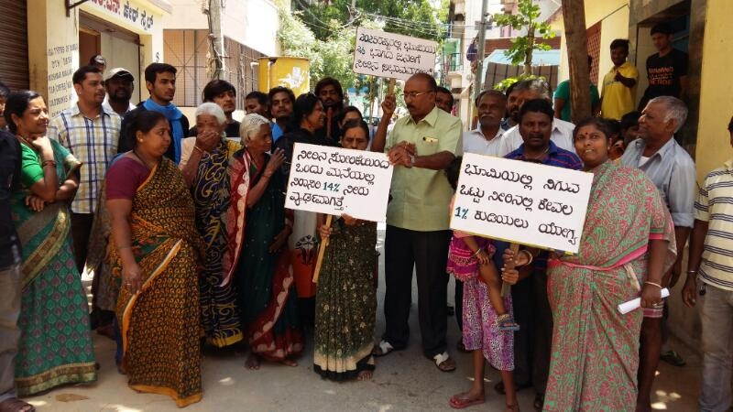

Sarathi also highlighted this issue in one of its seminar talk in health dept’s health educators seminar. If you visit my personal FB, Shamanthaka Mani… You can watch live performance and hundreds of responses advocated association of white field and youth for change group joined their hands with Sarathi.
Special thanks to Naveen… as a resource person representing BWSSB spoke to students in their academic language good introduction thanks Naveen
Also, A.R shivakumar and sarala also have shared their Knowledge, Our official commitment is only street play but under individual and social responsibility, we sarathi broadcasted street play details performance in white field area. In these areas, our radio has 80% listenership.
Shamantha
Sarathi

Street play performed by M/s.Abhinaya Taranga on 30.03.2017 at
Avalahalli bus stop

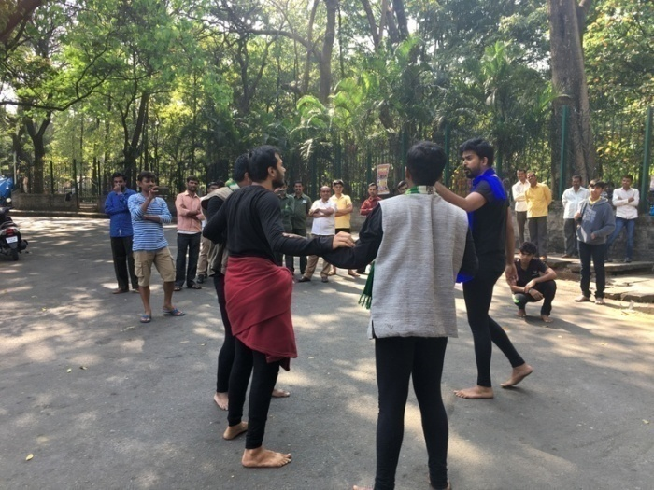
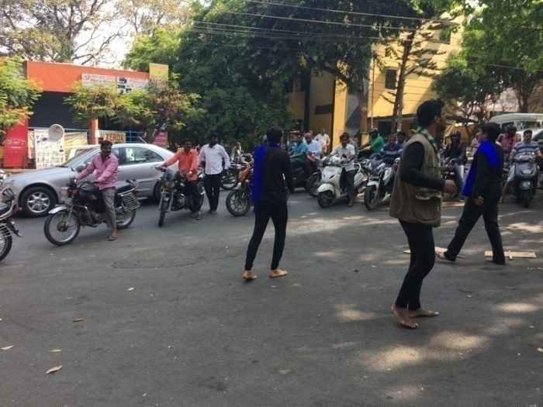

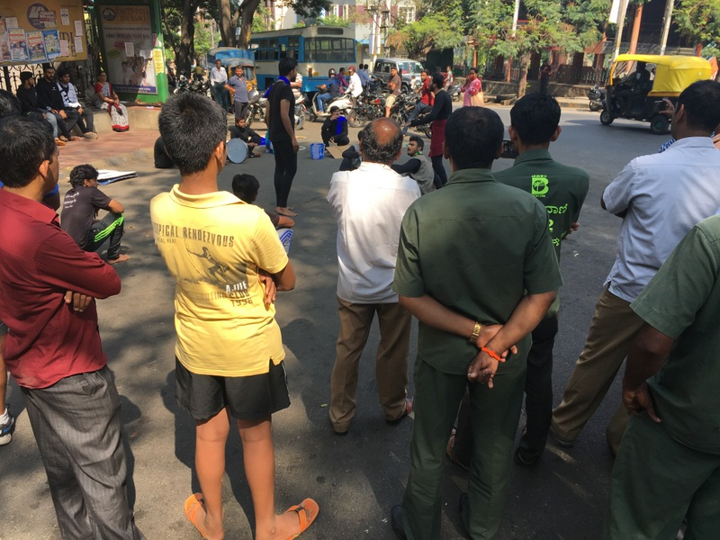

Street play performed by M/s.Abhinaya Taranga on 30.03.2017 at
Hoskerehalli Park
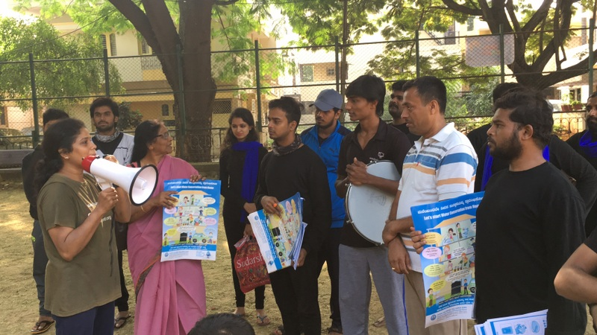

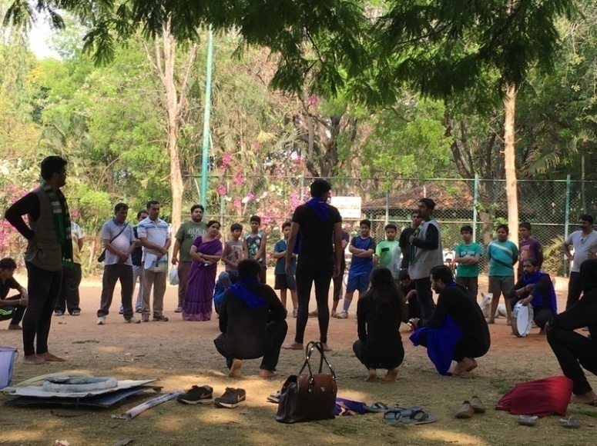

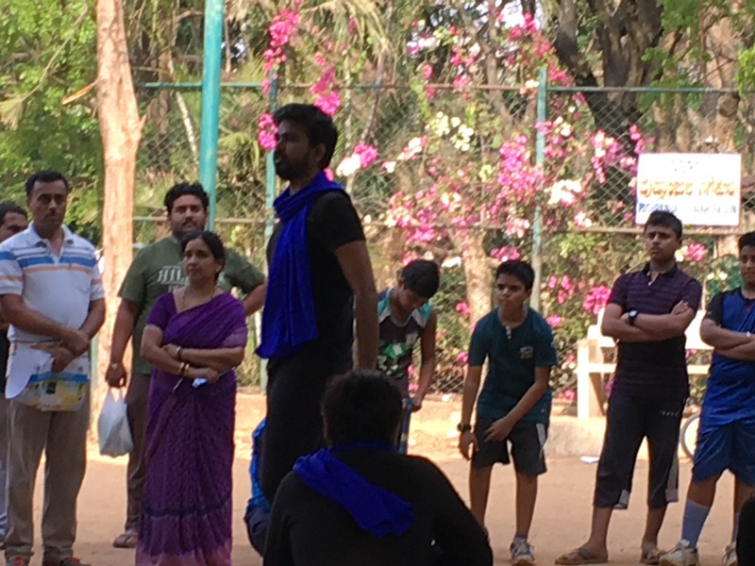

Street play performed by M/s.Abhinaya Taranga on 30.03.2017 at
Bugal Rock Entry

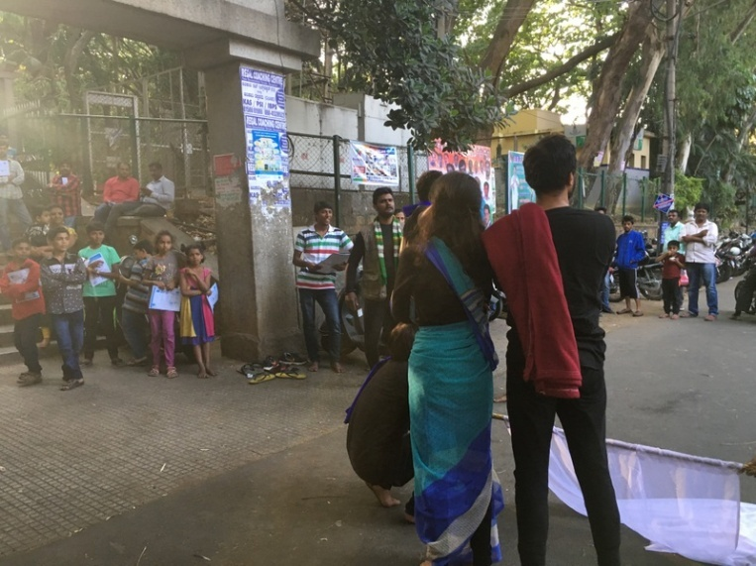
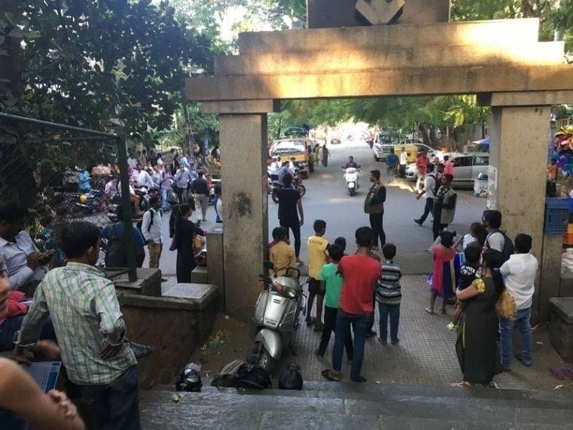
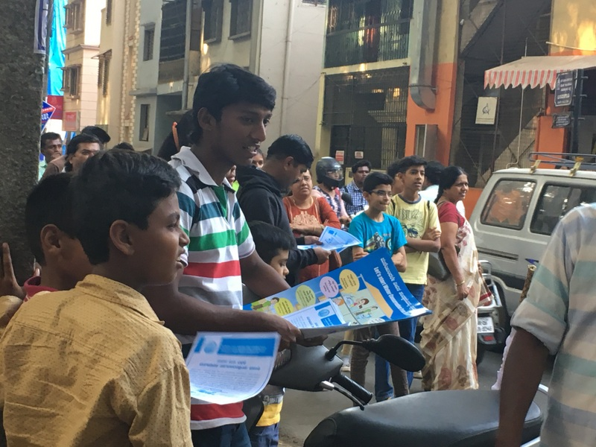

Street play performed by M/s.Abhinaya Taranga on 30.03.2017 at
Ganesh bhavan

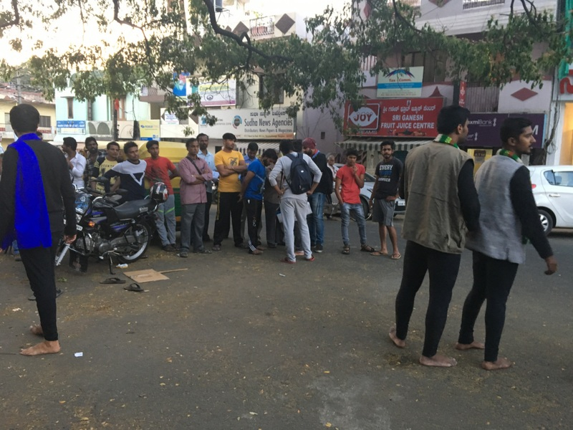

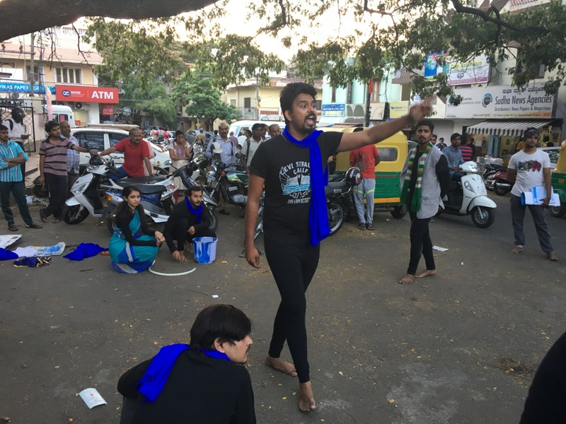

Street play performed by M/s.Abhinaya Taranga on 30.03.2017 at
Girinagara Park

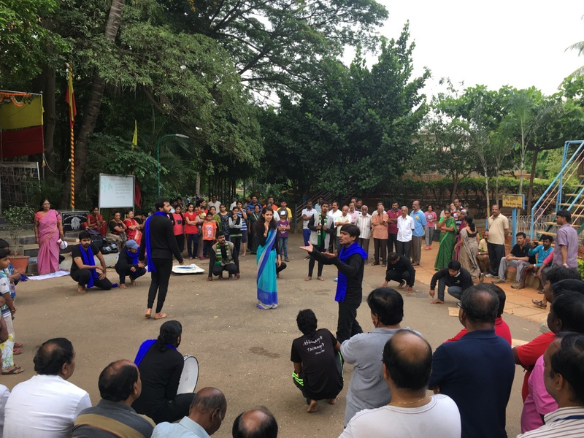
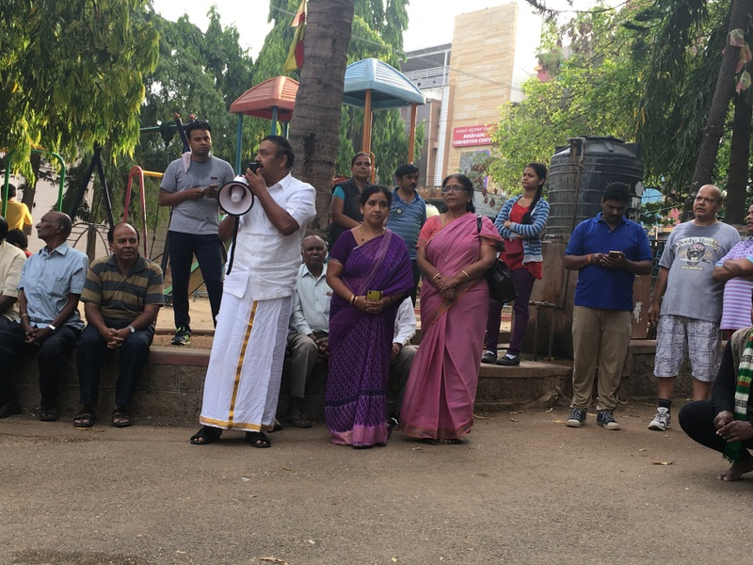
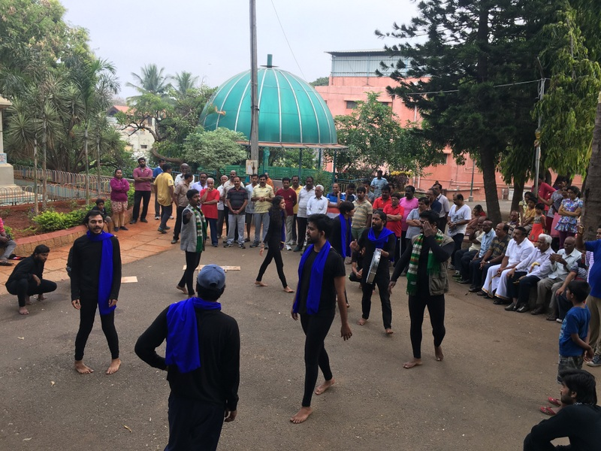
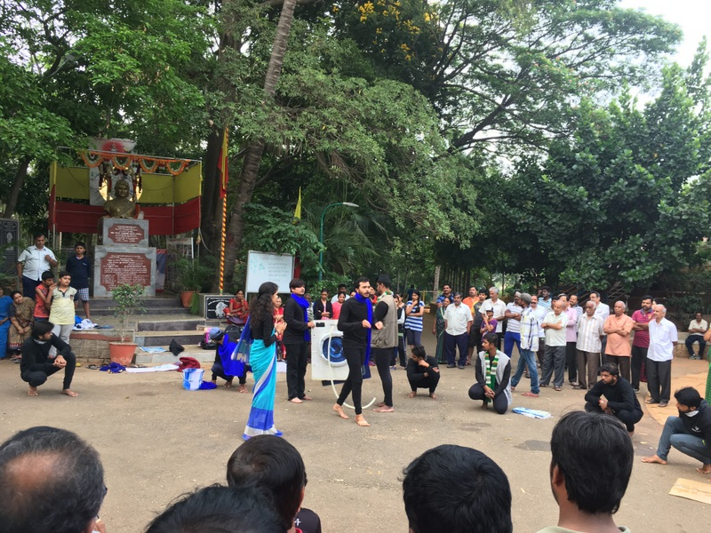

Street play performed by M/s.Abhinaya Taranga on 31.03.2017

Harihara gudda SLV Corner Gandhi bazar

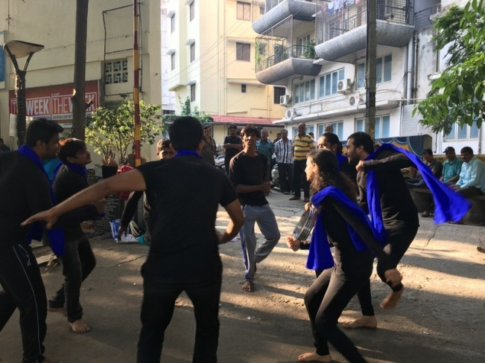
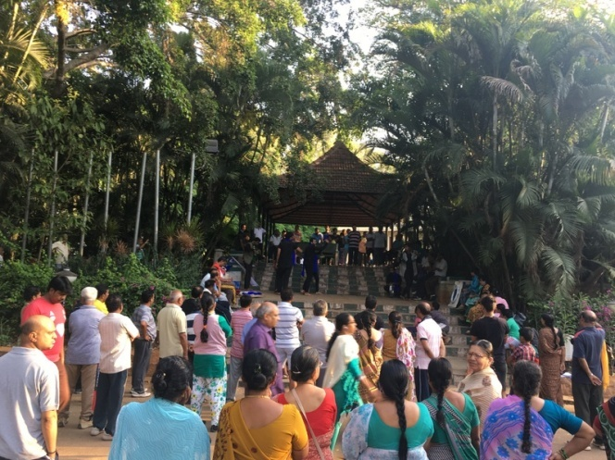

Near National co op bank Nettakallappa circle

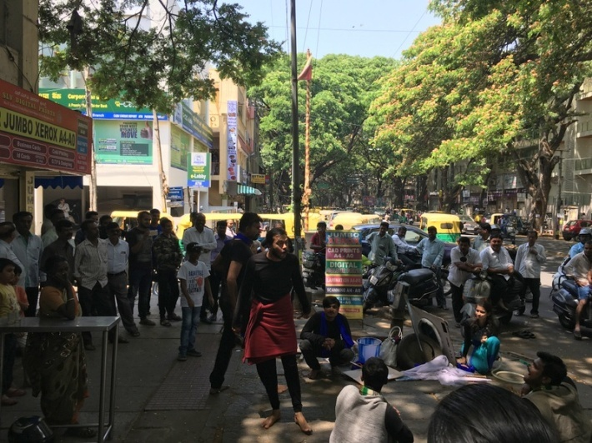
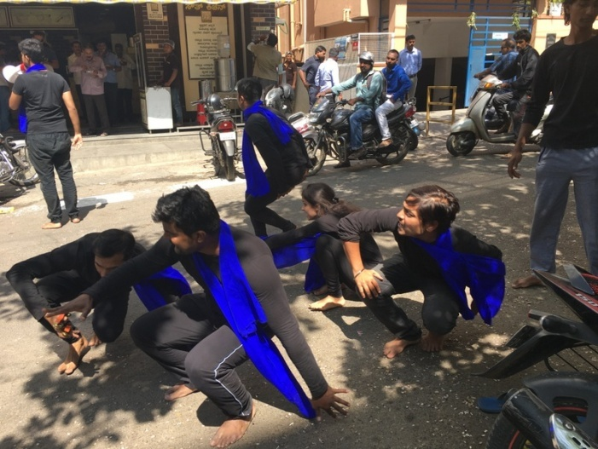

Street play performed by M/s.Abhinaya Taranga on 07.04.2017 at
Nagarabhavi

Ambedkar college Buddha park

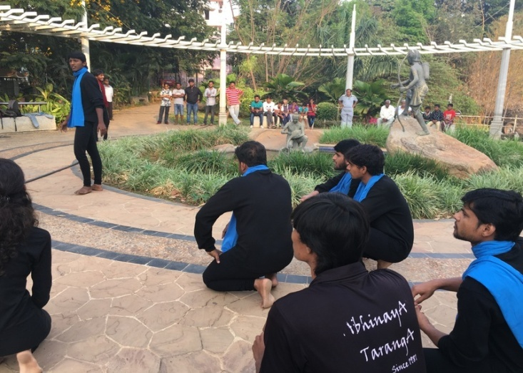
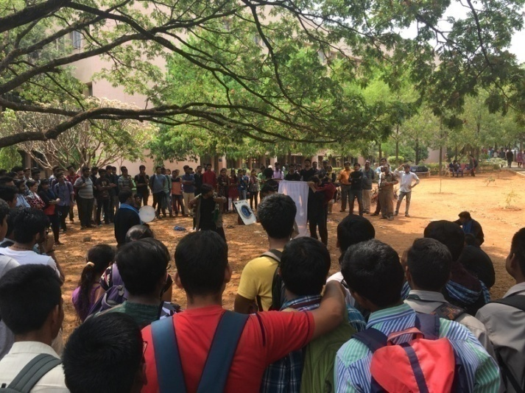

Nagarabhavi circle BDA Complex nagara bhavi

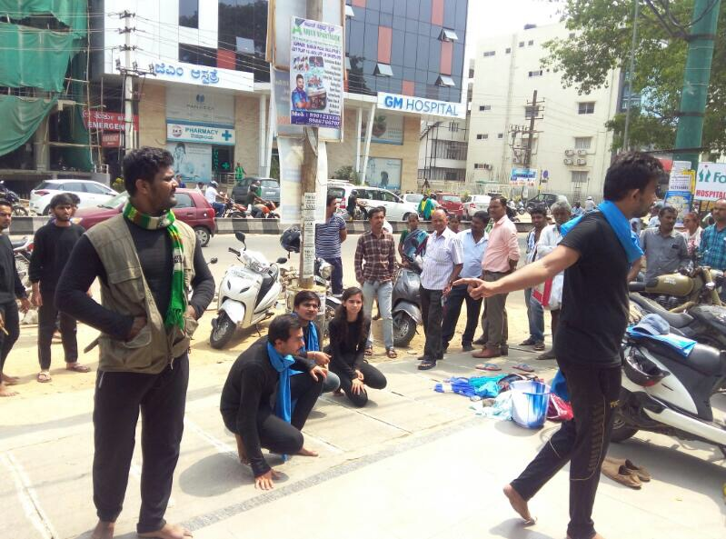
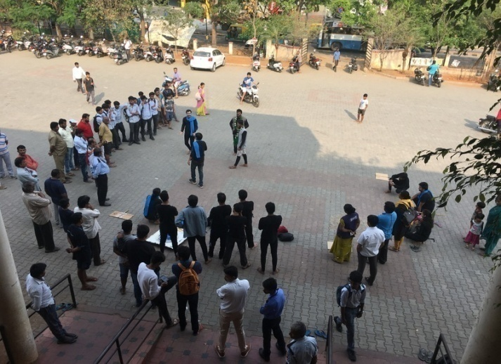

Street play performed by M/s.Abhinaya Taranga on 08.04.2017 at
Chamarajpet

Jinke park Makkala koota
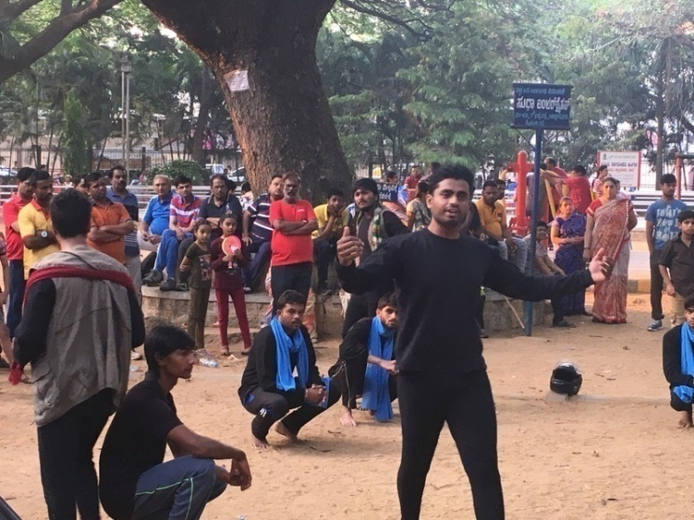

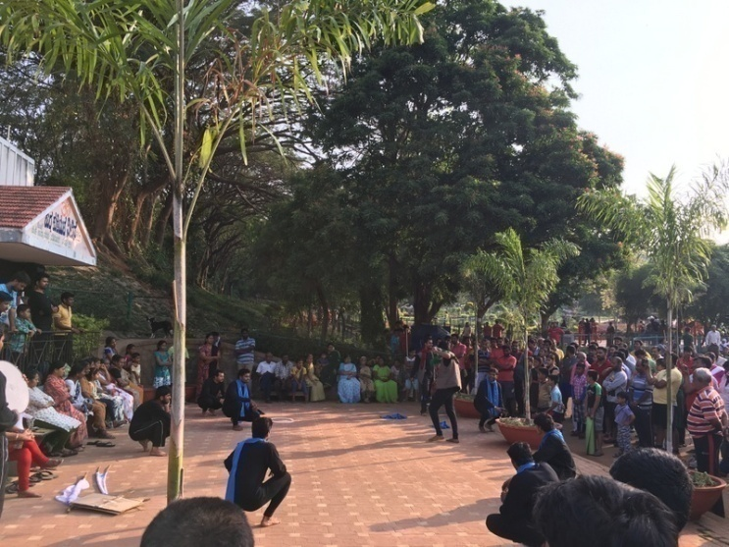

Police quarters Near Uma theatre
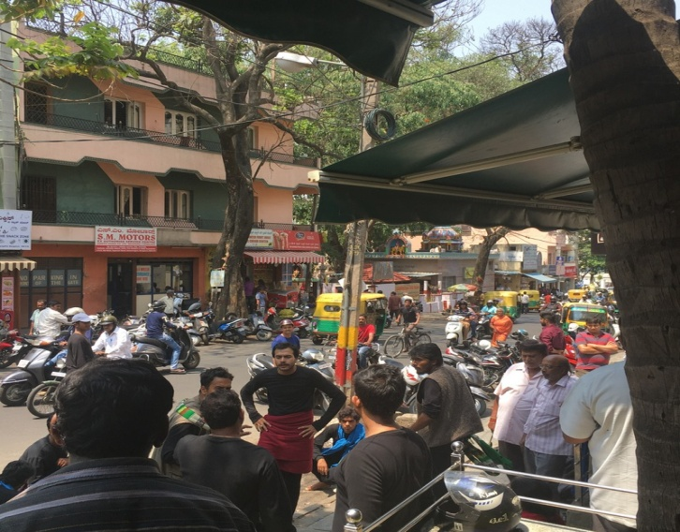
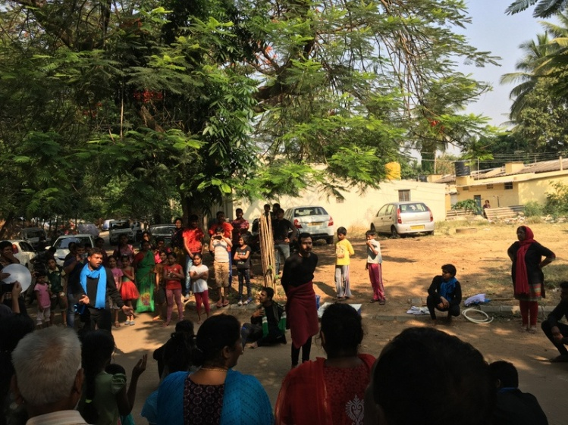

Street play performed by M/s.Abhinaya Taranga on 09.04.2017 at Lalbagh

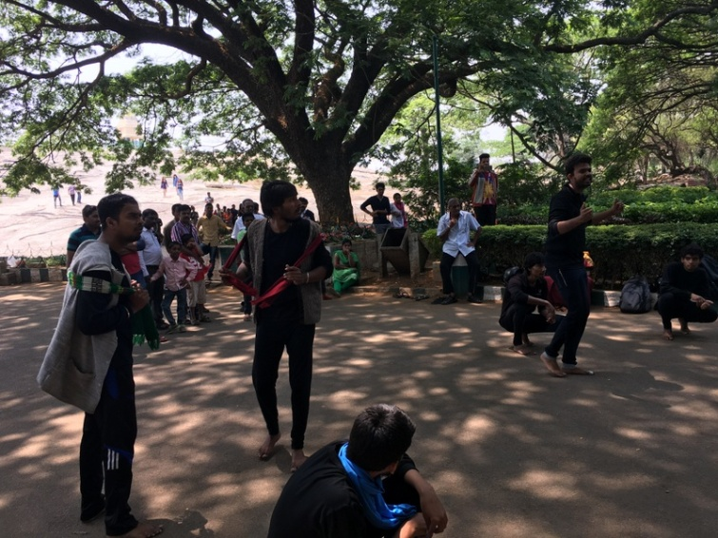
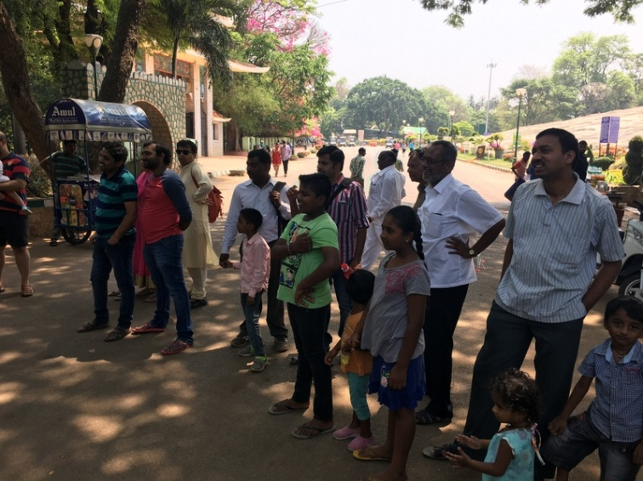
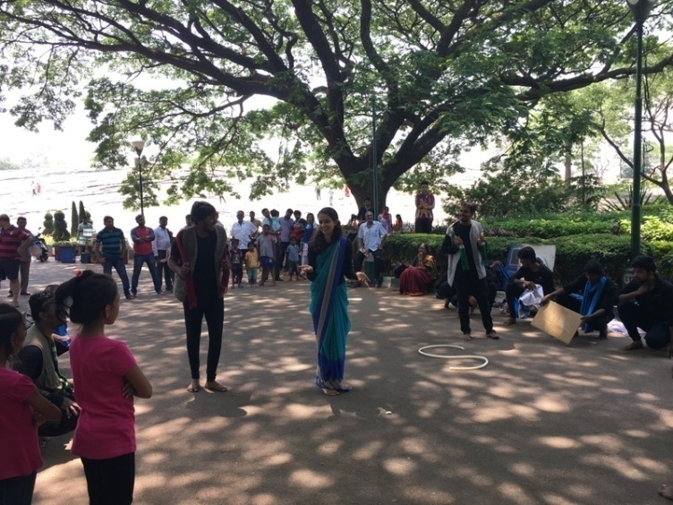
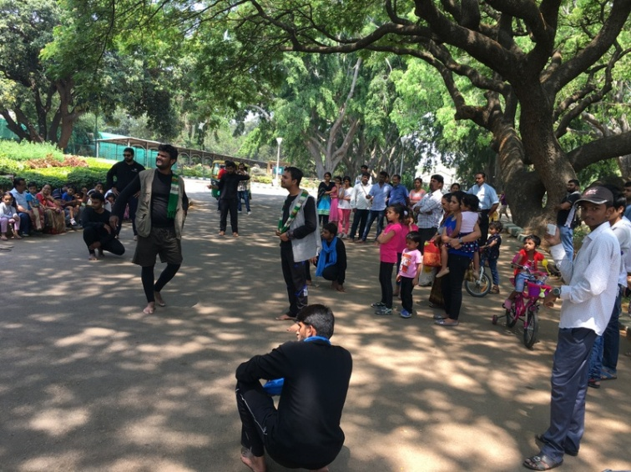

Street play performed by M/s.Abhinaya Taranga on 09.04.2017 at
Cubbon Park

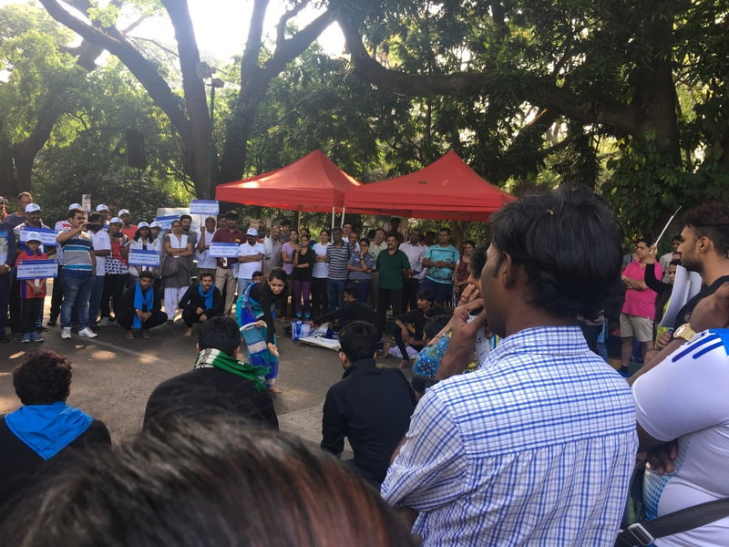

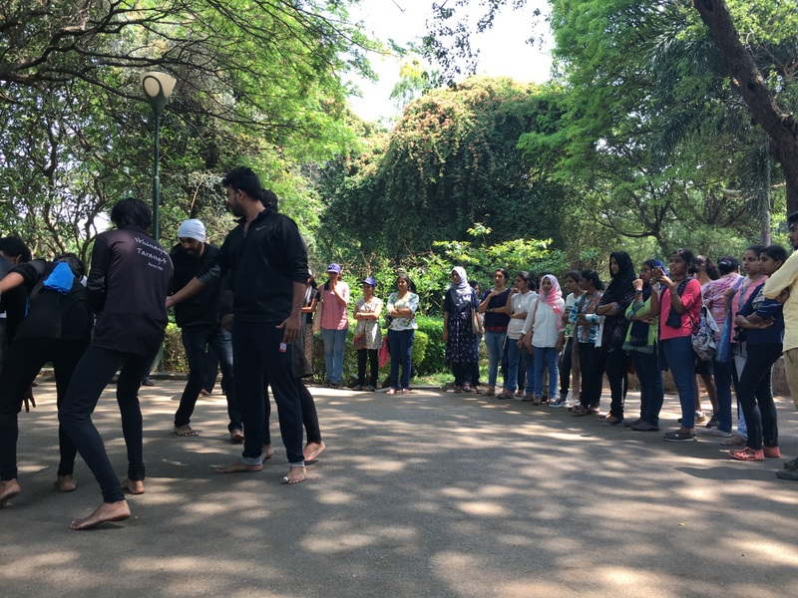

Save Water - Save Bengaluru Programme conducted by
M/s. Bird Tree International at Sri Jayachamarajendra Polytechnic on 10.04.2017
